MINOR PROJECT VALIDATION FORM

Supervisor Name |  | Panel Head
 | Dr. S. Ashwini | Dr. S. Jagadeesan
 | Faculty Advisor | Project Domain
 | Dr. S. Ashwini | Agentic AI
M
 | Student(s) Details: Name | Passport size photo(s)
 | - Adhira Srikanth  - Pooja Ellanti |   

Registration Number(s)

1. RA2311003011023
2. RA2311003010147

Email ID(s)&Mobile Number(s)
1: as2611@srmist.edu.in  8939640520 | 2: pe4111@srmist.edu.in  9154315236

1 | Abstract | Artificial Intelligence systems in healthcare and finance require strong mechanisms for fairness, transparency, and regulatory compliance. MAICA is a multi-agent framework that automates AI auditing by evaluating security, bias, and explainability to generate structured compliance reports
2 | RESEARCH GAP | 1.Lack of automated auditing and multi-agent systems  2.Limited AI compliance frameworks  3.Manual evaluation inefficiency
3 | Please furnish the details of 5 research articles in IEEE Reference format with Impact factor and year of publication from Which Research gap has been identified (F. Lastname, “Title of article,” *Journal Name*, vol., no., pp., year. And IF 3.1)) / 5 Patent Details for highlighting the innovation | 1.S. Phiri, “Creating Characteristically Auditable Agentic AI Systems,” ACM Transactions on Intelligent Systems and Technology, vol. 16, no. 2, pp. 1-18, 2025. IF: 3.5  2.A. Marino, L. Conti, and F. Russo, “Automating EU AI Act Compliance Analyses Using Rule-Based AI Models,” IEEE Access, vol. 12, pp. 45621-45634, 2024. IF: 3.9  3.R. Agarwal, M. Gupta, and K. Shah, “Multi-Agent Knowledge Graph Systems for Regulatory Question Answering,” IEEE Transactions on Knowledge and Data Engineering, vol. 37, no. 4, pp. 2150-2162, 2025. IF: 5.2  4. J. Manheim, “AI Audit Standards Boards and the Governance of Algorithmic Accountability,” AI and Ethics (Springer), vol. 5, no. 1, pp. 55-70, 2025. IF: 4.1  5.D. Raji, A. Smart, and T. Mitchell, “Closing the AI Accountability Gap: Defining Auditing Practices for Machine Learning,” Proceedings of the IEEE, vol. 109, no. 12, pp. 2142-2160, 2021. IF: 20.6
4 | Bridging the Research Gap/ Innovation Gap | 1. Lacks practical implementation and comparison with automated auditing frameworks.  2. Focuses only on rule translation without runtime monitoring or explainability integration.  3.No empirical compliance auditing or performance comparison with manual auditing.
5 | OBJECTIVE | 1.Automate AI auditing  2.Detect model bias  3.Ensure regulatory compliance  4.Improve AI transparency  5.Enhance ethical AI
6 | System Architecture | 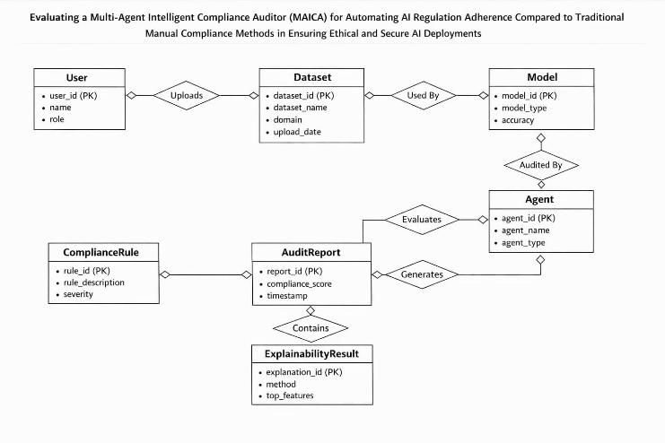
7 | METHODOLOGY | 1. Dataset collection  2.Data preprocessing  3.Model training  4. Multi-agent design  5. Security auditing  6. Compliance rule evaluation  7. Explainability analysis
8 | OUTCOMES OR DELIVERABLES  (not more than 5 points) | 1. AI compliance framework  2. Automated audit reports  3. Bias detection results  4. Explainability insights  5. Interactive dashboard
9 | NOVELTY  (not more than 3 points) | 1. Multi-agent auditing framework  2. Automated AI compliance evaluation  3. Integrated bias & explainability auditing
10 | Time line | Deliverables
 | February 28, 2026 (SPRINT Review 1) | Developed MAICA (Multi-Agent Intelligent Compliance Auditor) that trains AI models using healthcare and finance datasets and automatically audits them for fairness, security, and regulatory compliance using multiple intelligent agents. The system generates structured compliance reports with explainability insights and compares automated auditing results with traditional manual compliance methods to evaluate effectiveness.
 | March 22, 2026 (SPRINT Review 2) | Implemented enhanced MAICA framework with improved auditing agents, including bias detection, explainability, and compliance modules. Integrated user interface components such as dashboard visualization and chatbot interaction. Evaluated system performance using multiple datasets and refined model accuracy and auditing efficiency.
 | April 28 – 30,2026 (Project Demo and Report submission) | Final system demonstration was successfully completed, showcasing the MAICA framework with AI-based investment advisor and multi-agent compliance auditing. The project report was finalized, reviewed, and submitted. Minor improvements and documentation corrections were also incorporated based on feedback.
11 | Collaboration details | 1. Team members collaboratively worked on implementing the MAICA multi-agent system, dataset preparation, and model development.  2. The team jointly analyzed results, prepared reports, and discussed future integration of the compliance auditing system into a healthcare/finance web application.
12 | Target Technology Readiness Level of the project  (TRL Scale 1 to 9). | Target Technology Readiness Level (TRL): TRL 5 – Technology validated in a relevant environment  The MAICA system has achieved TRL 5, where the technology has been validated in a relevant environment using real-world datasets from healthcare and finance domains. The prototype demonstrates automated AI compliance auditing, including bias detection, security evaluation, explainability analysis, and structured compliance report generation.
13 | Sustainable Development Goal (1-17) (Most prominent one goal) | Sustainable Development Goal (SDG 9): Industry, Innovation, and Infrastructure  SDG 9 focuses on building resilient infrastructure, promoting sustainable industrialization, and fostering innovation. The MAICA system supports this goal by introducing an innovative AI governance framework that improves transparency, compliance, and responsible AI deployment in critical industries such as healthcare and finance.
14 | Industry Practice followed for system development (Agile- SCRUM) | The MAICA system was developed using the Agile–SCRUM methodology, which divides the project into small development cycles called sprints. This approach enables continuous testing, improvement, and efficient collaboration while developing modules such as dataset processing, auditing agents, and the compliance dashboard.

Conference/Journal Publication/Patent Details : The research work titled “Application-Integrated Multi-Agent AI Governance Framework for Automated Compliance Auditing” was successfully presented at the 14th International Conference on Contemporary Engineering and Technology (ICCET 2026), organized by the Organization of Science & Innovative Engineering and Technology (OSIET), Chennai, in collaboration with Samarkand State University, Uzbekistan.
The conference was held on 22nd and 23rd March 2026 at Prince Shri Venkateshwara Padmavathy Engineering College, Chennai, India.
The paper has also been submitted for publication in IEEE Xplore, highlighting its research contribution and relevance in the domain of AI governance and compliance auditing.

Signature of Students: 1.
2.

Signature of the Supervisor:

